* *Split the column CITY and separate the code associate with each city like - Allahabad[AL2] should be only Allahabad and [A2] will be separate.*

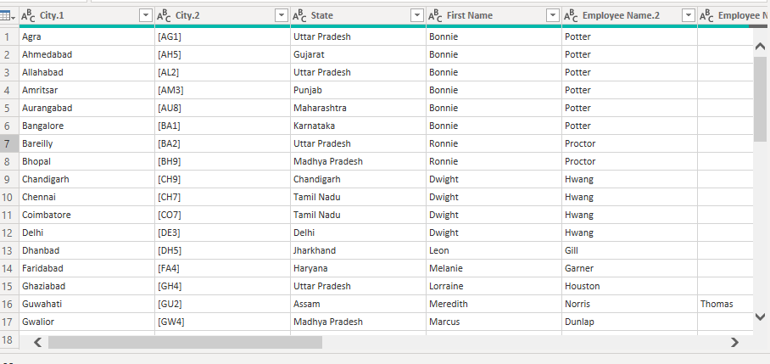

* *Extract the first name from EMPLOYEE NAME column and transform the column*

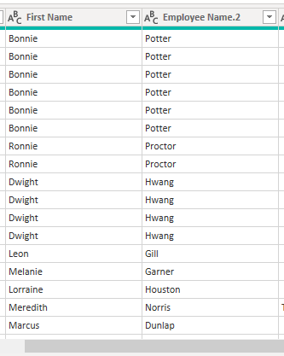

* *Using the JOINING DATE column extract the Year and no. of days for that month .*

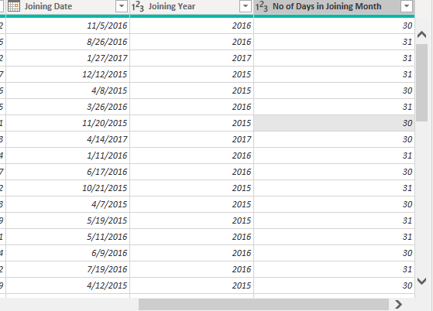

* *visual of your choice and show the how much salary has been paid to each state and which state has lowest payout.*

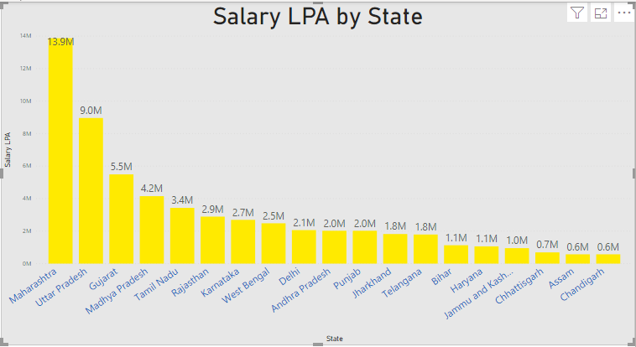

Chandigarh has the lowest payout.